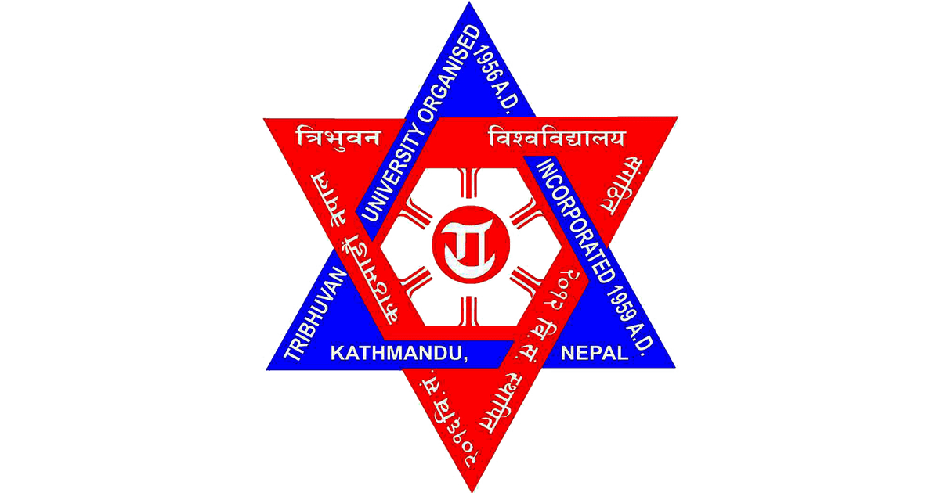

**Tribhuvan University**

**Faculty of Humanities and Social Science**

**Saraswati Multiple Campus**

Lekhnath marga, Kathmandu

**Society And Technology Report**

**Submitted By: Submitted To:**

Name: Bikram Gyawali Name: Mrs.Radhika Dahal

Roll No: 22

Level: BCA (1st Semester) ………………………………

Subject: Society and Technology Signature

Subject Code: CACS 102